introduction

In this essay, I would like to examine the teaching of the high school trigonometry chapter in a 5-unit course, to stand on a particular teaching approach and offer it pedagogical guidance through geograba-built widgets. The essay is not a textbook and is primarily intended for teachers and those engaged in mathematical education who wish to become familiar with the pedagogical approach presented in it and make use of the materials offered.

1 Teaching Trigonometry - Reviewing literature and mapping goals and difficulties

The chapter "Trigonometry" in the Israeli curriculum includes two sub-chapters: solving geometric problems in plane and space using trigonometric functions, and defining trigonometric functions on a real variable using the unit circle. The first sub-chapter clearly connects to the chapter on Euclidean geometry and the second sub-chapter to the chapter on functions. In fact, it is one of the opportunities, which is not common in the curriculum, to use functions to solve problems with an applied dimension. Importantly, it can be argued that each of the above-mentioned chapters stands on its own, so there seems to be no impediment to teaching and studying these chapters in any order.

In the light of the above, I would like to explore in this chapter both options for teaching trigonometry and for examining the pros and cons of each approach. The first approach, which is the most widely accepted approach, is to define the trigonometric functions as ratios of rib lengths in right angles. The second approach is to define the trigonometric functions as the rates of points obtained by rotating a vector radius from the beginning of the axes. The realistic starting point is that high school students only begin to study trigonometry after learning the following chapters:

• Euclidean geometry (including circle and triangle similarity)

• Basic concepts in the polynomial functions chapter including tangents and derivatives

• Analytical geometry (including the housing of a single radiuso circle in a Cartesian axis system, so that it is centered at the beginning of the axes)

Below, I will explore the difficulties encountered in the research literature in studying the trigonometry chapter.

It is important to note that the difficulties described were learned from world research literature and were not examined in the Israeli context. The first difficulty relates to the definition of trigonometric functions as the relationship between ribs in a right-angled triangle (hereinafter the triangular approach) (Thompson, 2008). When you calculate the sine of an angle by dividing a perpendicular opposite the angle with the rest of a right-angled triangle, there is a gap between the calculation operation and the fact that the function argument is the angle. Usually missing during the instructional transition of organs in the definition of the function that are angles and the range of length ratios, or in other words, it is unclear what the function is of the angle, when what the student is required to do is length actions. Looking at angle as a continuous variable and the insight that in each right-angled triangle with a given angle, the corresponding relations between sides of a triangle will remain constant, both complex and necessary to enable a student to tell a coherent story about the meaning of the trigonometric functions defined by angles at right angles. Other difficulties that can arise if choosing the triangular approach are due to the function being defined on an open domain, that is, the independent variable receives all the actual values ​​between zero degrees and ninety degrees excluding the edges. Knowing the behavior of the sine and cosine functions in this field, for example, ascending and descending, is not understandable and requires dynamic geometric constructions. To illustrate, you can look at a circle that has a single diameter and all the right angled triangles that are blocked in a circle so that a given diameter is allowed. The variability of one of the extras can be examined according to the variability of the circumferential angle that rests on the perpendicular. See Figure 1 and link:

https://www.geogebra.org/m/rgrfwhft.

If you move the point D without changing the diameter of the circle, you can see that as the  increases, the perpendicular to the opposite and the smaller perpendicular to it grows.

Another difficulty in opening the instruction in the triangular approach is derived from the default measurement of angles in degrees of degrees. We will discuss this difficulty in detail later.

In light of the above, I do not wish to rule out the opening of the chapter instruction on trigonometric functions with defining the ratio of length-function functions in right-angled triangles. On the contrary, this teaching approach should be part of every teacher's repertoire, but consideration should be given to the integrity of the course, the difficulties it has and the possibility of providing students with a coherent story.

Another approach to chapter instruction relies on the definition of trigonometric functions on the unit circuit (Spain and Pearl 1990) (hereafter the geometric approach). The common move is to define rotations by extending the angle concept. The turns are measured in degrees. The degree of rotation is positive when the rotation is counterclockwise and its degree is negative when it is clockwise. The independent variable is a rotation measured by the motion of a beam that exits from the beginning of the axes relative to the beam that is the positive part of the x-axis. The values ​​of the trigonometric functions are determined by the rates of the intersection points of the beam with the unit circle and with different tangents, see Figure 2 (the file can be reached at the following link: https://www.geogebra.org/m/ndzvfb5h)

The main advantage of opening the subject in this approach is that the cyclic properties, symmetry and definitions of the trigonometric functions are derived directly from the definition on the unit circle. From here the graphical representation of the four functions can be produced and after establishing the students' familiarity with the functions it is possible to narrow the field of definition and discuss the usefulness of these functions for calculations in straight angles and geometric shapes in general.

The disadvantage of the approach is that the functions are defined on a variable of degrees, which makes it difficult to derive the functions. This is because to find the derived function we have to replace the independent variable to be measured in units of radians.

The transition to defining the trigonometric functions of a variable that measures radian rotations is a familiar landmark for teachers. Although I did not find research that trigonometry teaching 5-unit track according to the Israeli curriculum, the gut feeling is that many students do all tasks and exercises with a variable of degrees and when the problem is in analysis (i.e. when using trigonometric derivatives) they convert the final answers To radians automatically. This does not mean that this pedagogical approach is improper, only to be taken into account.

In this essay I would like to introduce a new approach for defining the trigonometric functions on the unit circuit. This is an approach whose uniqueness is in the initial definition of the trigonometric functions on an actual variable that is equivalent to a variable measured in radians. Justifying the choice of the unique functional approach is not because it is an optimal pedagogical move, but because it should be part of each teacher's repertoire. It should be a teacher's expertise to exercise judgment and choose a pedagogical approach that suits her students' needs.

2 Functional approach with radians - the main stages of pedagogical retirement

2.1 Defining the Trigonometric Functions and Revealing Their Properties

Every choice during a pedagogic for teaching a mathematical subject has its advantages and disadvantages. The uniqueness of the approach shown below is to assimilate the trigonometric functions as functions that are operationally defined on an actual number that represents rotation in units of radians. Its advantage is that it offers a solution to the ambiguity of using the word "degrees" once as a measure of angle and a second as a measure of rotation which is the field of definition of the trigonometric functions. The solution to this difficulty lies in defining the trigonometric functions differently than it does when it is based on the abstract concept of the function (known from the middle school), on measuring the arc length of a circle, on the unit circle housed in the Cartesian axis and without relying on partial definitions designed to solve problems. This approach is recognized in the research literature (Moore, 2012) as well as in textbooks (Rimon and Pearl 2005). In this essay, I would like to lay out the pedagogical move for teachers who teach trigonometry at the high levels and accompany the move with widgets that can help with teaching. In the first stage I will examine the relevant basic concepts.

2.1.1 Why radian?

A function is defined by a particular match between a field organ and a range organ. The only test that the "pass" definition needs is the test of the acceptable function definition. Thus, each element in the field will fit a single organ in the range. Thus, there is no fundamental obstacle to setting the trigonometric sine function on a degree of rotation, so that the units of measurement are degrees (one degree is defined as part of the 1/360 of a whole rotation). We need to recognize that the sine function defined on a variable of degrees and the sine function defined on a variable of radians are two different functions. To illustrate the variance, I will show the graphs of sin (x °) and sin (xrad) in the same axis system (Figure 3 ).

It seems that when we teach trigonometric functions on both degrees and radians, students are unaware of this variation between the different representations of the graphs. In practice, students seem to regard the field of trigonometric function as something that represents a part of a rotation. In other words, as far as the students are concerned, it doesn't really matter what is written on the x-axis as long as there is agreement that it represents that part of the rotation. This leads to a situation where there is no consistency in marking the numbers on the x-axis and it seems that in more than one class we can find graphs of the following shape (Figure 4):

The above representation is particularly problematic when the covariance between the numerical values ​​of x and sin (x) occupies a central place in the class discourse, that is, when the discourse is rotated on the derivative of sin (x). Here, a decision is required, since from Figure 3 it can be easily concluded that the tangent gradients of the functions of sin (x °) and sin (xrad) are different for equal values ​​of x. We must choose one of the above two functions to represent sin (x) and then the other will be its stretch or collapse. The decision, which function to choose, can be made based on looking at the graphs of the derived functions of the two given functions plotted in the same set of axes together with the function graphs (see Figures 5 and 6).

We note that it is difficult to detect the variability of the sin (x °) derivative even when we have modified the scale so that we can see the sin (x °).

Looking at Figures 5 and 6, we can see that the derivative of sin (xrad) is cos (xrad) while the derivative of sin (x °) is acos (x °) where a1. From this it can be concluded that for reasons of mere convenience, the choice of defining the trigonometric functions on a radian type variable can be justified. Of course, there are other considerations for selecting a radian as a variable of the trigonometric functions and some of them will appear later in this connection. Another useful read can also be found in a blog post: "How Good is Radian on Us" - by Gadi Alexandrovich at link: https://gadial.net/2008/01/11/radians/ And in the book "Learn and Teach Analysis" pages 371-373 .

2.1.2 Introduction to Cyclic Functions - Winding Action

The unique feature of trigonometric functions is that they are cyclic functions. It is possible to identify the periodicity feature while teaching the trigonometric functions, but it is also possible to precede and discuss similarly defined cyclic functions, thus giving an opportunity for the spiral development of the class discourse. I learned the idea I will describe below with training for 5 teachers at the Weizmann Institute in the beginning of my teaching career. If my memory does not mislead me, the teacher was Zippora Resnick. (Activities can be found according to the same principle in "Learning and Teaching Analysis" activity 1 pages 353-354).

The idea is to build a match between real numbers based on imaginary (or real) thread wrapping on a geometric shape. Here are some examples: We have a square in a Cartesian axis, so that its sides are parallel to the axes and the length of each side is two units. Given an actual number x, we will cut a (imaginary) length that | x | And wrap it on the square, starting from point (1,0) (on which point B in figure 7). If x> 0 is clockwise and if x <0 is clockwise. When the wrap is complete, we will mark the endpoint at P (see Figure 7). The notion that should be at the center of the discourse is the periodicity feature of the correlation between the x rate of the point X and the point P. Then the fit can also be extended to one of the classes of the point P. For example, the point S in Figure 7 represents the correlation between the x rate of X and The y-rate of P.

The shape in which the yarn is wrapped can be changed and see how the variable of the point S. See a suitable file at the link: https://www.geogebra.org/m/rcqqcdxx. The file was built following (Demir & Heck 2013).

This experience can be done either by performing a task (see Appendix A) or by demonstrating in class, in any case it is worthwhile to have cyclic phenomena that have mathematical representation at the center of the classroom discourse. Another possible example of the cyclicity of mathematical functions relies on the widget at the following link: https://www.geogebra.org/m/QRmStjFg.

Illustrating using the SCRATCH software of winding and finding values of trigonometric functions can be found at https://scratch.mit.edu/studios/25046732 (thanks to Professor Moti Ben-Ari for the idea and implementation).

3 Copy an actual number to a point on a circle

The construction process of a point obtained by winding can also be done on a unit circle centered at the beginning of the axes. Here, too, we get a cyclic correlation between the x rate of a point on the x axis and the endpoint of the winding. The adjustment can be built in the same hinge system (see link to the https://www.geogebra.org/m/wzsmbz9c applet) or in two separate hinge systems (see link to the https://www.geogebra.org/m/g3rdcmat applet). As with previous adjustments in which the wrapped shape was polygonal, even here the periodicity of the fit is determined by the extent of the geometric shape. Therefore, it is more convenient to look at the fit when the wrapped length is measured by the multiples of the neighboring cycle of the function and the circumference of their circle 2. This helps us to predict for what values ​​of x the point P will reach certain places on the circle. See link https://www.geogebra.org/m/c7whrntz. At this point, it is worthwhile to consider the practice of class matching by the type of questions: "In which quadrant is the point P corresponding to the number ...?" And the like.

The next step is to make the fit a function of a single real variable in the range (as opposed to matching the rates of a point which are two real variables). First, define the function s (x) as a correlation between an actual number and the y rate of the point P. It is assumed that mathematics teachers reading this essay immediately recognize that we have just defined the sin (x) function on a radian type variable. However, discretion should be exercised as to whether it is appropriate to disclose the function name to students at this stage of study. It makes sense when choosing to set the trigonometric functions in the approach shown below, as much as possible to reject the link to the trigonometric functions defined on right-angled triangles (assuming that students know one way or the other the definition of right-angled triangles, whether from math and physics / mechanics classes) . The basis of this correlation between real numbers should be fixed within the context of a geometric definition of the unit circle of functions as a fit between each limb in a single limb in range and not in the context of connecting with other familiar functions.

The following is the graphical representation of the function definition s (x):

In figure 8 above we see a split window: in the right window is the function and in the left window is the geometric construction that defines the function. The arc variable is the independent variable, which is applied to the unit circle starting at point (1,0) as explained above. The y-rate of P is the dependent variable of the function and the point marked in the axis (the y-rate of P, arc) represents the correlated variance of the function s (x). To obtain the graphical representation of the function, you can leave a trace of the point (the y-rate of P, arc) and obtain the following graph in the right window (Figure 9): The widget is in the following link:

https://www.geogebra.org/m/fbmpfnsa

The graphical representation of the function reveals the periodicity of the function that can be listed as follows:

s (x) = s (x + 2πk) k∈Z

The additional symmetry properties of the function derived from its definition on the unit circle can now be examined and how they are expressed in the graph.

Let’s look at the arc in the unit circle beginning at (1,0) and the point P corresponding to it. We will reflect the point P with respect to the rate axes and the beginning of the axes and we will examine what can be said about the arcs that correspond to the points received. Note that in Figures 10 and 11, the point Px and Py are the reflections of the point P with respect to the x and y axis, respectively, and the point Pxy represents the reflection of P with respect to the beginning of the axes. Also points G, B, H and I are the intersection points of the unit circle with the lesson axes.

If we denote the degree of the arc that point P corresponds to x, then the degree of arc (PI) ̆ is also equal to x and therefore the degree of arc that point Py corresponds to is π-x and hence we conclude that: s (x) = s (π -x) and similar considerations we conclude that s (x) = - s (π + x) and also s (x) = - s (-x) and hence the function is odd.

Next, the computational benefits that can be derived from the cyclicality and symmetry features that are derived from the function definition must be examined. For example, one might ask:

Find three different numbers whose s (x) values ​​are ½.

For which of the following numbers, the same value of the function s (x) is obtained and for which values ​​the opposite values ​​are obtained. π / 3, π / 4, π / 6, - 5π / 3, 2π / 3, 7π / 6, 7π / 4, -4π / 3, π / 3, 5π / 6.

After further establishing and practicing, one might consider introducing the second trigonometric function c (x) as a correlation between an actual number and the x rate of point P. Consider the difficulty of matching two numbers, where the independent variable is the x rate of Points on the graph and the dependent variable is the x rate of the point P. These are two different mathematical objects with a similar name and so be careful not to create confusion. In this case. We recommend that you split the screens. As seen in Drawing 12 (and in Drawing 13 below).

Similar to the above interpretation of the sine function, the graphical representation of the dependence between the degree of the arc and the x-point of the point P, which is the trigonometric function called cosine, can be revealed by using the applet at <https://www.geogebra.org/m/nj9bqxf5>

Below, consider the cyclic properties and symmetry of the new function using the same graphs (see Figures 10, 11) and conclude that:

cos (x) = cos (x + 2πk) k∈Z

And so cos (x) = - cos (π-x), cos (x) = - cos (x + π) and also cos (x) = cos (-x) and hence the function is a pair function.

A number of possible paths can be addressed at this point, one of which may be suitable for teachers or advanced classes listed in Exhibit C and it explores how to define similar functions to the basic trigonometric functions by adjusting point rates obtained by wrapping on another circuit.

Another dilemma is whether to choose to continue the moving phase of the trigonometric functions defined so far (sine and cosine) or to continue to define the tangential trigonometric functions (tangent and cotangent). I guess every choice is legitimate. A teacher can exercise judgment here and there. In this essay, I choose to move on with the familiar trigonometric functions because before I add new mathematical objects, I want to establish the class discourse that trigonometric functions as static mathematical objects and not merely represent the processes of these function definitions.

2.1.4 Moving the tensile and contraction of the trigonometric functions sin (x) and cos (x)

Mathematics students in the Israeli education system learn about transformations (meaning epinational transformations) of functions in parallel with the subject learning functions in general. So, while learning a function or family of functions, the graphical representations of their transformations are also studied. From this, one can assume that students come to study the chapter on trigonometric functions when given the graph of the function f (x) they can plot the graphs of the functions f (x + a), f (ax), f (x) + a, af (x) ) Or any combination thereof. The question arises, what is the added value of examining the graphical representation of transformations on trigonometric functions? You can list several reasons for teaching this topic:

Further look at the trigonometric identities (and the content of the periodicity feature) learned through defining the functions on the unit circle centered at the beginning, and examining how they are reflected in the graphical representation.

Examine the graphs of sin (x) and cos (x) as horizontal slides of each other.

Identify the parameters that define a transformation according to the change they produce in the properties of the block, the length of the cycle, the extremes, or zeros in the graphs that the transformation produces.

Didactic Note: Assuming that we want to use illustration using dynamic widgets, we must consider the best representation of the main feature whose variability we seek to demonstrate. Technology allows us to create continuous and rapid change. Such variability can leave a strong impression on the viewer. See for example the function at the following link: https://www.geogebra.org/m/pff9bvvt. Consideration should be exercised when a dynamic presentation allows the teacher and her students to develop a fruitful discussion and allows students to participate in coherent mathematical practice. In the case of the applet above, it seems preferable, certainly in the early stages of teaching the subject, to give up the dynamic demo and adopt a static approach where students invent functions that are transformations of trigonometric functions that are known to have predefined cyclic properties, blocks, and more. Students use technology to test their hypotheses (see Yael Norrick's lesson mentioned above).

The possibility of enriching or expanding the world of trigonometric functions for the definition of tangent and tangent functions may be to look at the functions csc (x) = 1 / sinx or sec x (x) = 1 / cosx, to recognize the existence of cyclic functions with a non-straight definition domain The real.

2.1.5 The tangential trigonometric functions

After establishing the discussion of sine and cosine functions, one can turn to define additional cyclic functions using the unit circuit. The acceptable choice is, first, to define the tangent function as a correlation between an actual number (which defines the degree of the bending arc and the intention) and the y-rate of the straight point of intersection connecting the main and the point of the arc (P) with the tangent to the unit circle x = 1. See drawing 14 below.

You can use the applet at the following link: https://www.geogebra.org/m/wwkyjdmb

The tangent function demonstrates to students a cyclic function with a cycle of  that is not set on any real straight line (or in school language, it has infinity of non-definite points). Observing the geometric feature that leads to a non-defining point of the function (two parallel straight lines do not have a cut point) can deepen students' ability to talk about the phenomenon of infinite entanglement. When the degree of arc is π / 2 (or π / 2 + πk, k∈z) there is a geometric argument that justifies the parallel of x = 1 and straight OP. You can also go in the opposite direction and adjust to any real number M, as large or small as desired, the length of the arc (up to a period of מח) so that the straight OP will cut straight x = 1 at a point (1, M). This move demonstrates that the tangential trigonometric function tangent receives any real value.

In exactly the same way, the function cot (x) can be defined except that this time the tangent equation will be y = 1 and the fit will be between an actual number that defines the arc and the x rate of the cut point of OP with y = 1. In the Israeli system for reasons of short-term it is common to omit the geometric definition instruction and the cot (x) function and then look at function 1 / tanx or cosx / sinx to deduce the features of the cot (x) function.

A teacher who chooses to teach the cot (x) function by its geometric definition can use the widget at the following link: https://www.geogebra.org/m/knsq2j69 Below is a screenshot:

Discretion should be exercised to determine whether it is time to reveal the relationships between all known trigonometric functions, and in particular the tan⁡ (x) = (sin⁡ (x)) / (cos (x)), cot⁡ (x) = (cos⁡ (x)) )) / (sin⁡ (x)) and 〖sin〗 ^ 2 (x) + 〖cos〗 ^ 2 (x) = 1. If one decides to reveal the connections in the current timing, it should be borne in mind that this involves looking at triangles similarities (the observation of triangles within the circular construction may have attracted the most attention). In order for the signs of the functions to be taken into account as well (and not just the value of the decision), it is necessary to convince the correctness of the claims for every possible situation on the unit circuit. Here are two examples in drawings 16, 17 aimed at convincing the correctness of the connections mentioned above: (See widget at link https://www.geogebra.org/m/bdfe2ygs)

2.1.6 Enrichment

In the previous step the functions csc (x) = 1 / sinx and sec⁡ (x) = 1 / cosx were mentioned. The introduction was based on arithmetic familiar geometric functions that are well defined (by winding the unit circuit and finding the endpoint rates). It is now possible to ask whether these functions can be defined geometrically. In other words, whether from looking at the construction of the trigonometric functions (see Figure 18), can we find a length that can represent these sizes? Following the connections mentioned in the previous section, and for considerations of triangular similarities, we can deduce from looking at Figure 18 the relationships | sec⁡ (x) | = OT and | cosec⁡ (x) | = OC. The following is a sketch of the proof:

According to the data in the drawing there is: OJ = OP = OB = 1. Also: OF = cos (x), PF = sin (x). From the similarity of the triangles ∆PFO ~ ∆OJC we will conclude: OC / OP = OJ / PF or in other words: OC = | 1 / (sin⁡ (x)) |. In the same way, from the similarity: ∆PFO ~ ∆TBO one can deduce OT = | 1 / (cos⁡ (x)) |.

2.1.7 Necessary chapters in study not listed in this essay

Before continuing to recognize the differential properties of the trigonometric functions, there are two main technical landmarks that a student should be familiar with. One is the solution of simple trigonometric equations and the other expressing relations between ribs in a right-angled triangle using trigonometric functions. The use of trigonometric functions to express the relationship between ribs in a right-angled triangle can be concluded as follows:

There is a correlation between the degree of arc in the unit circle and the degree in degrees of the central angle that rests on the arc. Therefore, the trigonometric functions can also be defined on a degree type variable.

All right-angled triangles with a sharp angle of a given size α are similar.

Each right-angled triangle where a sharp angle α, (or its reflection) can be housed in a system of axes, so that the vertex α lies at the beginning of the axis and perpendicular to it is a market of α placed on the positive direction of the x-axis (see Figure 19).

For reasons of triangular similarity, it is easy to conclude that PC / OP = DE / OD and because OP = 1, and also PC = sin (α), DE / OD = sin⁡ (α) exists. In the same way it can be concluded that OE / OD = cos⁡ (α) and DE / OE = tan⁡ (α). At this point a new chapter can be opened that delves into the applications of solving trigonometric equations and trigonometric calculations to solve geometric problems in the plane. This chapter can also be rejected after the analysis and investigation of the trigonometric functions (the cost of this decision can be limited coherence in the proof of the sine function, as we will see below).

2.2 Analysis of Trigonometric Functions

In this section we will examine how the rate of change can be discussed, or the derivative of each of the trigonometric functions. We will consider two possible approaches that are presented in the book Study and Teach Analysis in a chapter on trigonometric functions (pages 391-393). In both approaches, use is required to determine that the smaller the arc length in a circle, the closer the ratio of the arc length along the string that rests on it to one.

2.2.1 The ratio of arc length in a circle along the string that rests on it

To show the variation in the ratio of the length of the bow along the string on which all we have to do is observe.

Drawing 20

But there is something deceptive about mere observation. On the one hand, to see the length of the arch, we need to keep the scale. That is to say, see in each picture the same part of the circle. On the other hand, the smaller the bow, the harder it is to give a quantitative assessment of the relation between it and the string that rests on it.

For those who are not convinced by looking at the series of paintings presented above, you can try to be persuaded with the following argument: It is known that the circumference of the circle can be approximated by the circumference of an elaborate polygon blocked by it. ZA The more ribs there are in the polygon, the closer the circumference is to the circumference of the circle.

Now, I know that the circumference of the circle divided by the number of ribs is the length of the bow on which the string rests in the rib. Therefore, if the ratio of the circumference of the circle to the circumference of the polygon approaches 1 as the number of ribs increases, so does the ratio of the length of the bow to the string on which it approaches 1 as the arc is small. (See the widget illustrating the illustration in drawing 20 at the following link: https://www.geogebra.org/m/cygxh8g3).

We can now express this boundary using the lengths represented by trigonometric functions.

If we want to find the limit lim┬ (x → 0) ⁡ 〖(sin⁡ (x)) / x〗 we can assume that it is equal in size (assuming the boundary exists of course) to the limit lim┬ (x → 0) ⁡ 〖(2 ∙ sin⁡ (x)) / (2 ∙ x)〗 And since this boundary is equal to the boundary of the ratio of the length of the bow along the string leaning on it as the length of the bow decreases (see Figure 21), we can conclude from the above argument that lim┬ (x → 0 ) ⁡ 〖(sin⁡ (x)) / x = 1〗.

2 Geometric approach

By this approach, the limit lim┬ (h → 0) ⁡ 〖(sin⁡ (x + h) -sin⁡ (x)) / h〗 is considered from looking at each of the components of an expression within the geometric context within which it is defined. We will look at the two arcs: x and x + h and the sections that represent the y rates of the points on the unit circle that correspond to the two arcs mentioned above. We will note that at this point in the instruction we can use the degree of arc and the degree of the central angle in radians that lean on the arc as identical sizes (represent the same actual number). First we will identify in the drawing the significant sizes for proof. See drawing 23:

The value x represents the point on the actual axis where we seek to find the derivative of sin⁡ (x). This value is represented by drawing (BP_x) ̆ or equivalently באופןP_x OB = x.

The value x + h represents the point on the actual axis that approaches the point x. This value is represented in the drawing by the arc (BP_ (x + h)) ̆.

Hence the degree of arc (P_x P_ (x + h)) ̆ is h.

The square GHDP_x is a rectangle and therefore (assuming we are in the first quarter) the length of the P_ (x + h) segment G is sin⁡ (x + h) -sin⁡ (x).

The angle∢ GP_ (x + h) P_x holds: ∢GP_ (x + h) P_x = ∢OP_ (x + h) P_x-∢OP_ (x + h) H

The triangle ΔOP_ (x + h) P_x is a triangular equilateral triangle where the angle of head is h

 ∢OP_ (x + h) P_x = π / 2-h / 2.

The triangle ΔOP_ (x + h) H is a right-angled triangle. ∢OHP_ (x + h) = π / 2, ∢P_ (x + h) OB = x + h and therefore ∢OP_ (x + h) H = π / 2- (x + h)

From Sections 6 and 7 we can conclude that ∢GP_ (x + h) P_x = x + h / 2

Now we can calculate the limit lim┬ (h → 0) ⁡ 〖(sin⁡ (x + h) -sin⁡ (x)) / h〗 by looking at the sizes we identified in the drawing. We note that for smaller and smaller values ​​of h it can be said that the length of the arc h can be approximated by the length of P_ (x + h) P_x and the angle ∢GP_ (x + h) P_x can be approximated by x. From here we will conclude:

lim┬ (h → 0) ⁡ 〖(sin⁡ (x + h) -sin⁡ (x)) / h = lim┬ (h → 0) ⁡ 〖(GP_ (x + h)) / h = lim┬ ( h → 0) ⁡ 〖(GP_ (x + h)) / (P_ (x + h) P_x) = lim┬ (h → 0) [cos⁡ (x + h / 2)] = cos⁡ (x)〗 〗〗

3 Algebraic approach

This approach is shorter and also relies on the limit lim┬ (x → 0) ⁡ 〖(sin⁡ (x)) / x = 1〗 In its algebraic representation also the continuity of the cos⁡ (x) function and the identity sin⁡ (α) -sin ⁡ (β) = 2 ∙ sin⁡ ((α-β) / 2) ∙ cos ((α + β) / 2). As an exercise, students can be asked to reveal the justifications during the following:

lim┬ (h → 0) ⁡ 〖(sin⁡ (x + h) -sin⁡ (x)) / h〗 = lim┬ (h → 0) ⁡ 〖〖2 ∙ sin〗 ⁡ 〖(h / 2) ∙ cos (x + h / 2)〗 / h〗 = lim┬ (h → 0) ⁡ 〖[(sin (h / 2) / (h / 2)) ∙ cos (x + h / 2)] = cos⁡ (x)〗

The choice between the two approaches should be made by choosing the skills we want to cultivate in the students. If we want to woo the geometric observation, the choice of geometric approach is self-evident. If, on the other hand, we want to use boundaries in the context of a continuum of functions, we choose the algebraic approach. It is important to note that in both cases the justification of lim┬ (x → 0) ⁡ 〖(sin⁡ (x)) / x = 1〗 is geometric as discussed at the beginning of the chapter.

The derivatives of the trigonometric functions can be found in various ways, one being the unique way that uses the knowledge of classical mechanics to learn about the degree of variability of the basic trigonometric functions. A translation of a related article appears in the following related CPA issue:

<http://newhighmath.haifa.ac.il/images/data2/alle55/Josevich_Alle_55_.pdf>

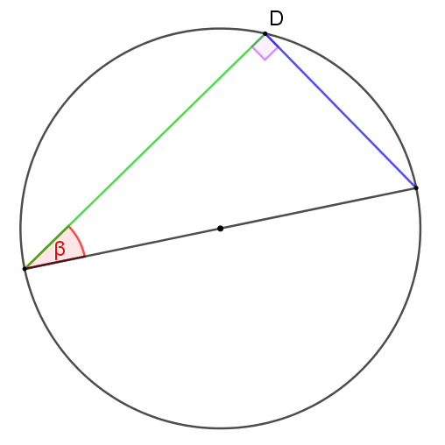

ציור 1

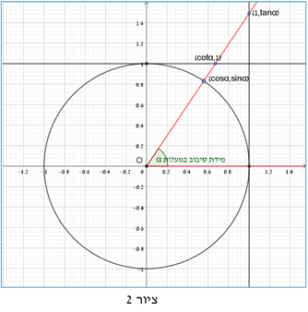

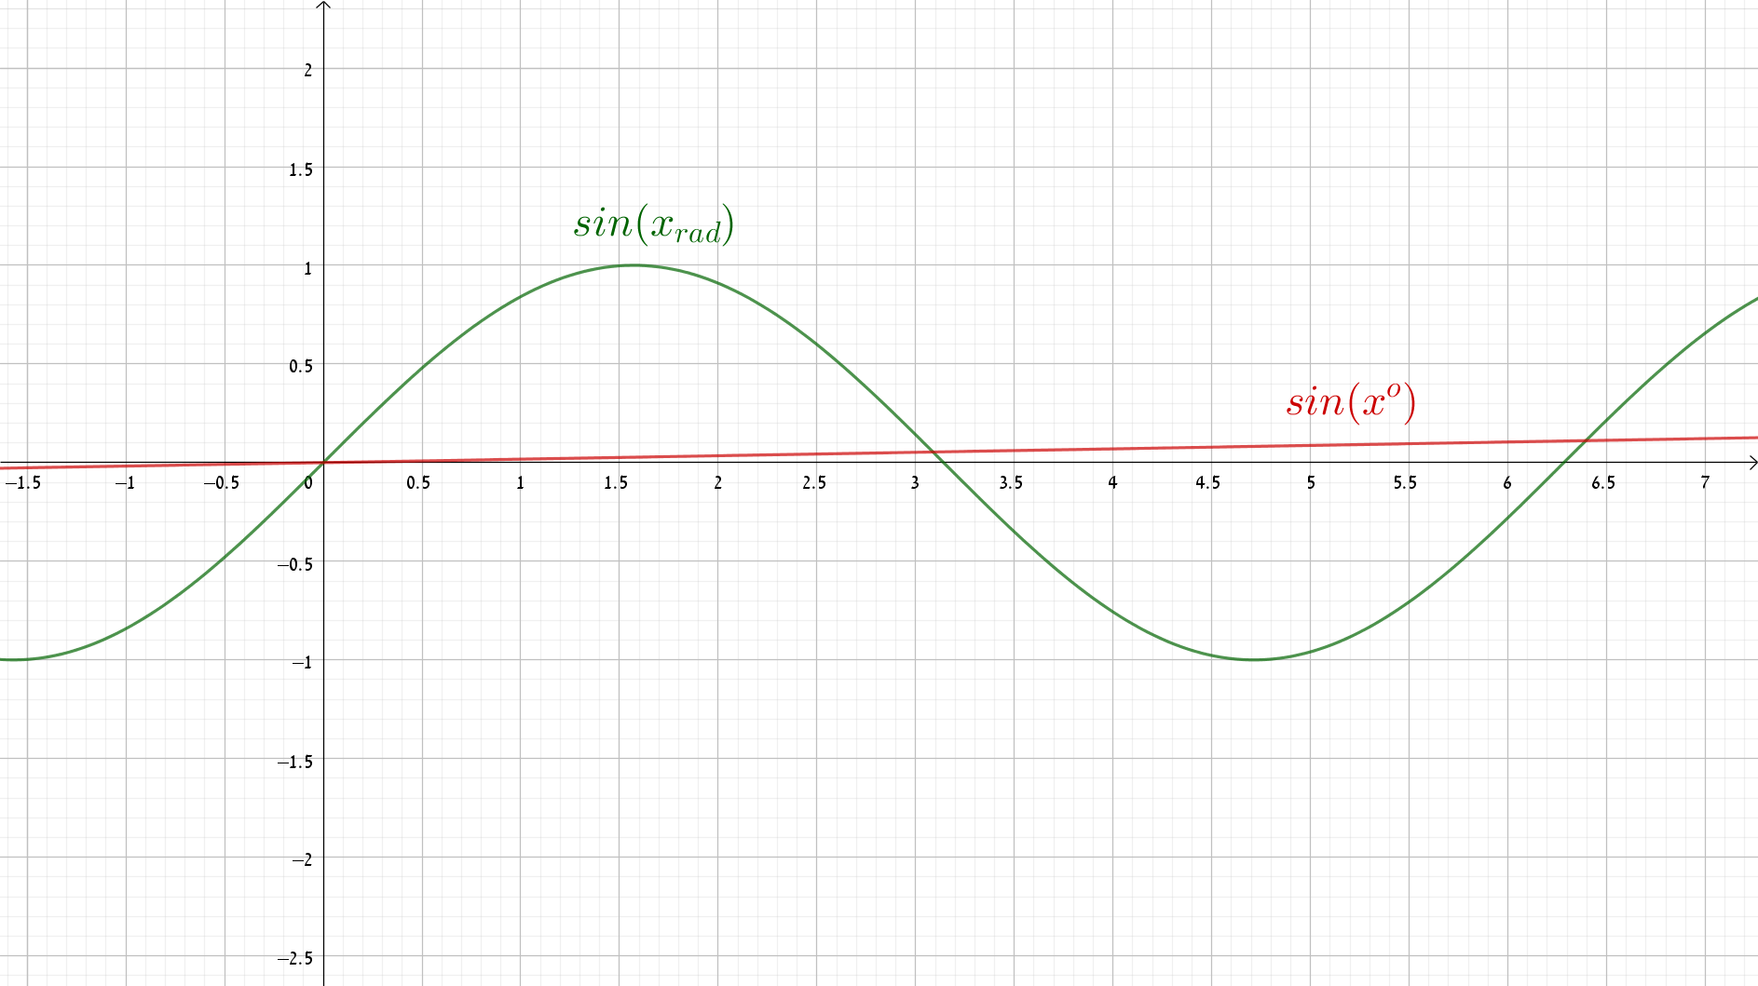

ציור 3

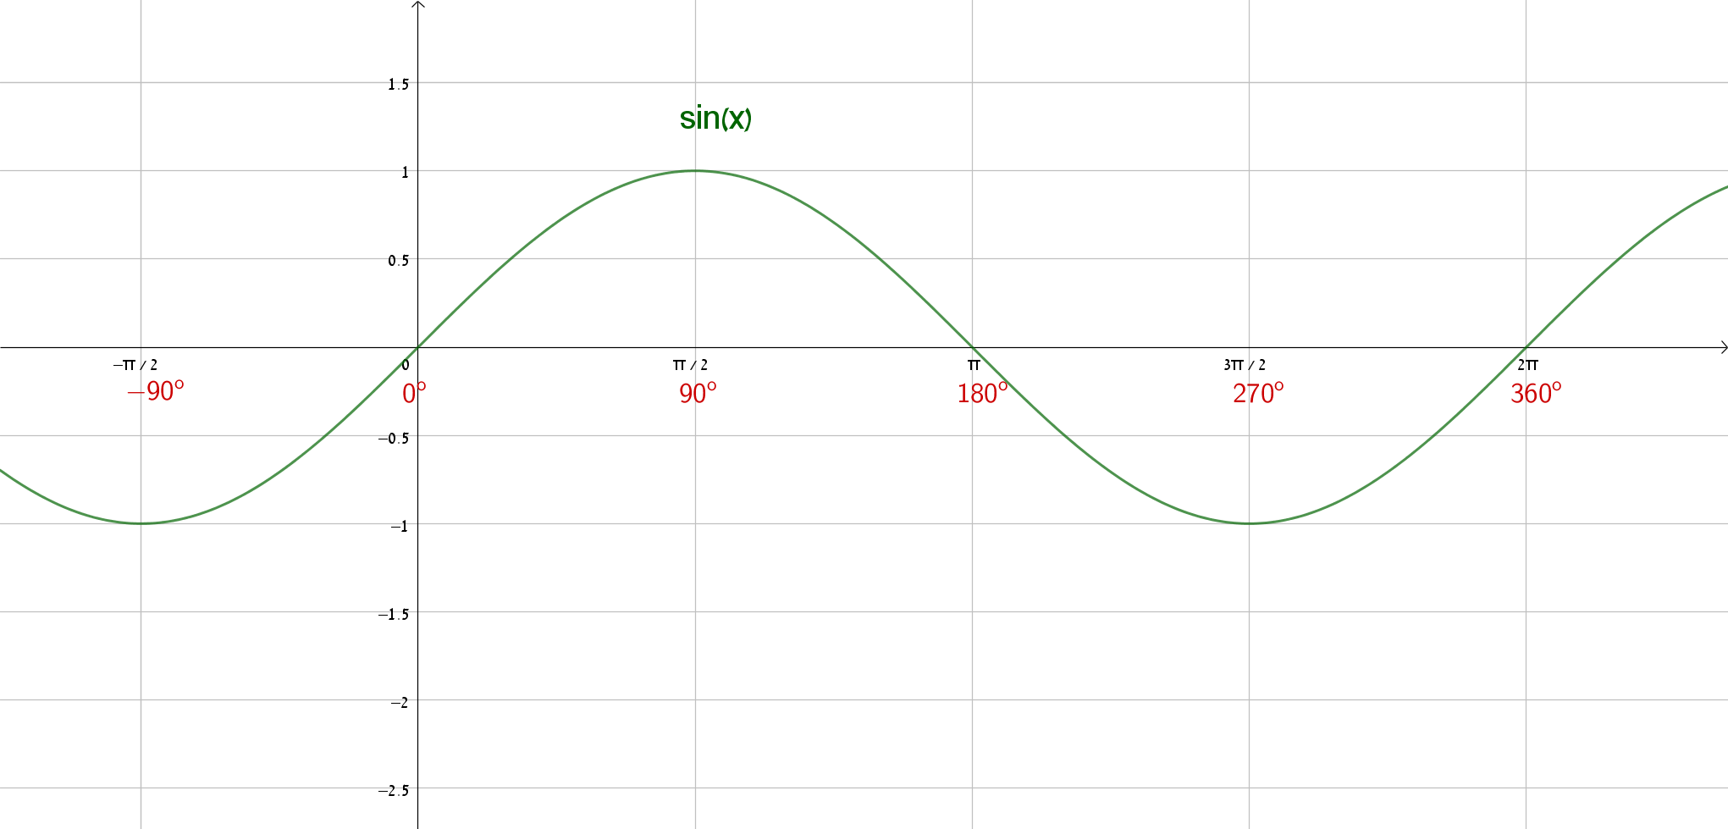

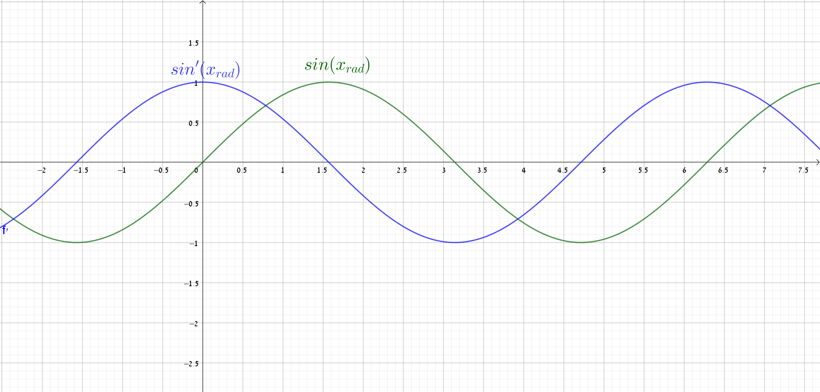

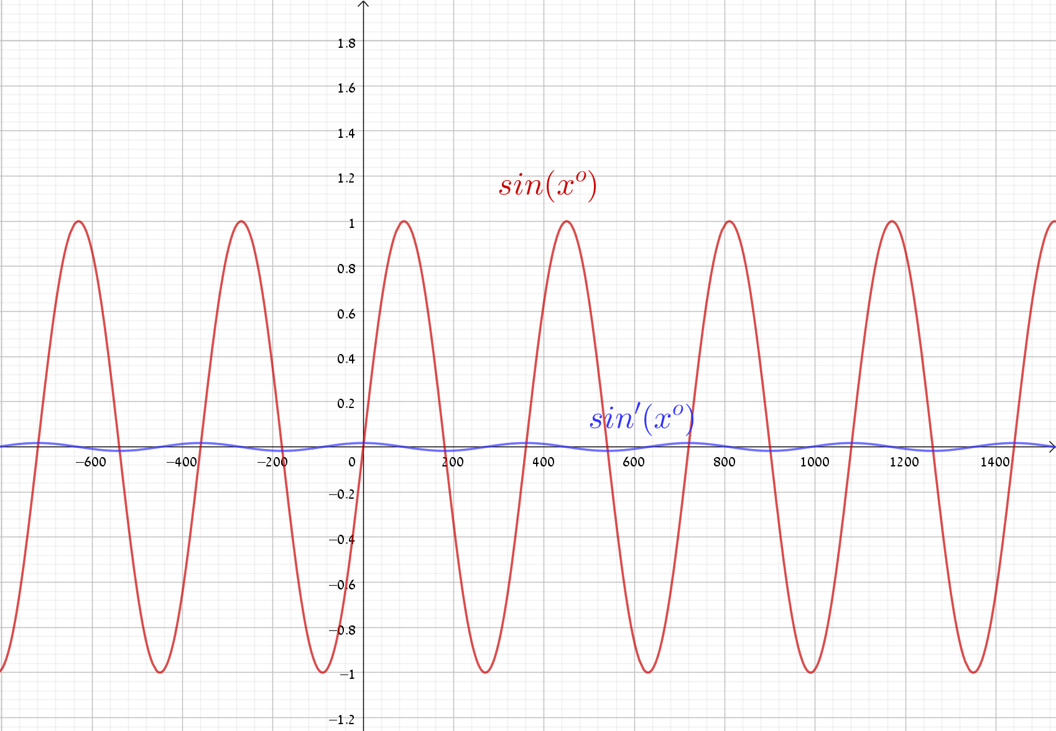

ציור 6

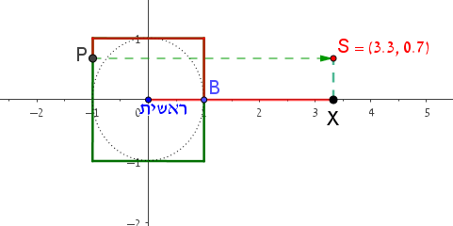

ציור 7

ציור 8

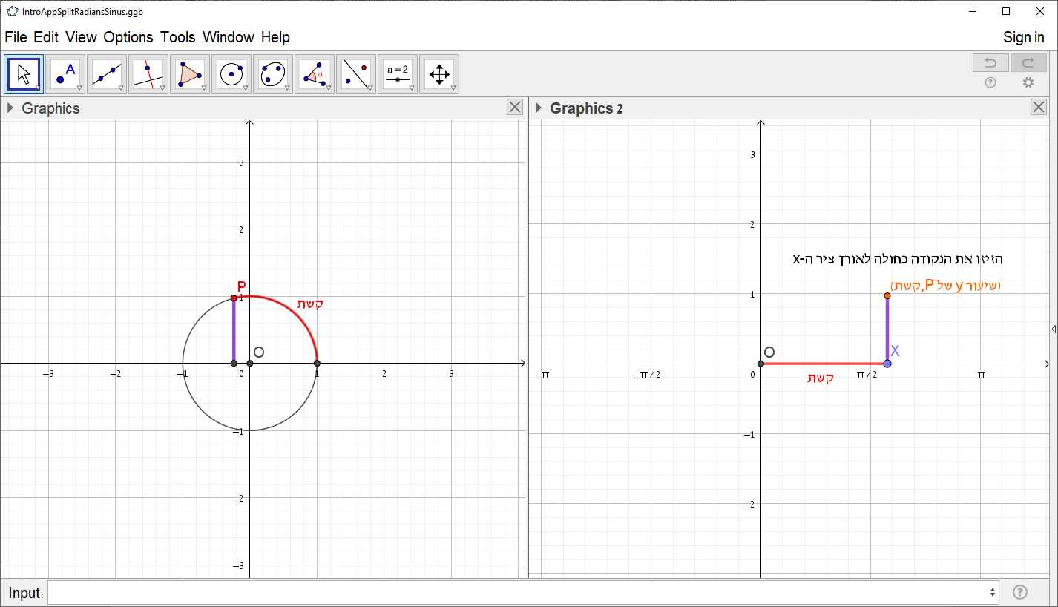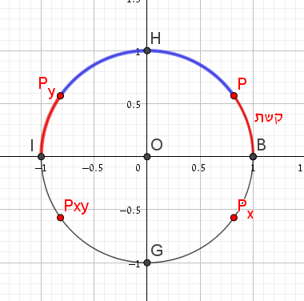

ציור 11

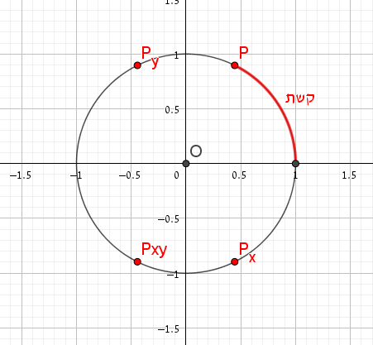

ציור 10

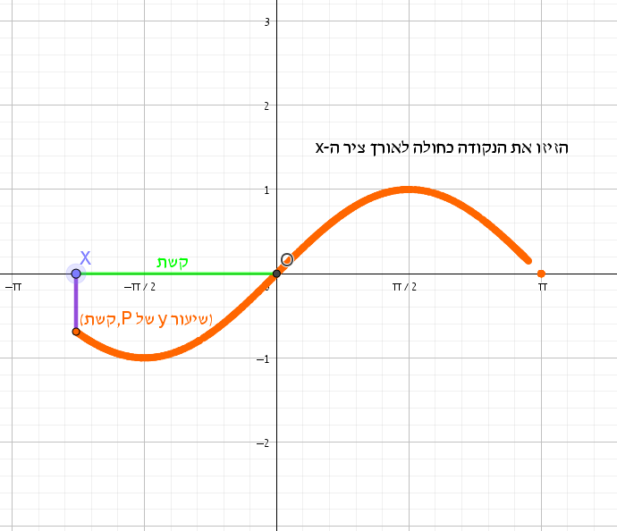

ציור 9



ציור 11

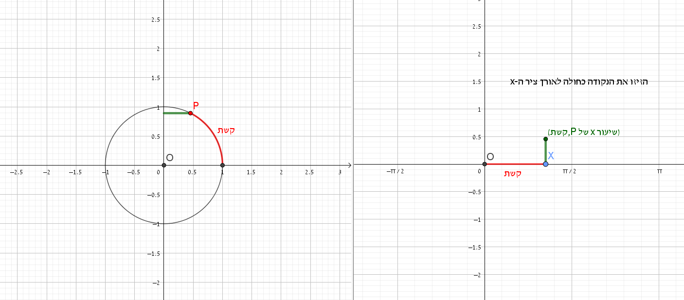

ציור 12

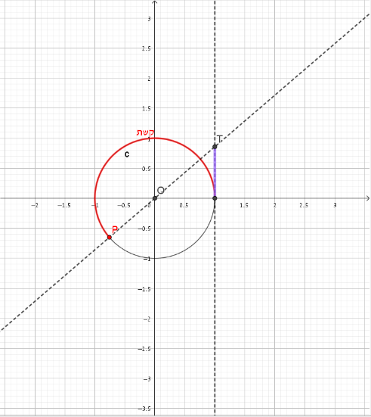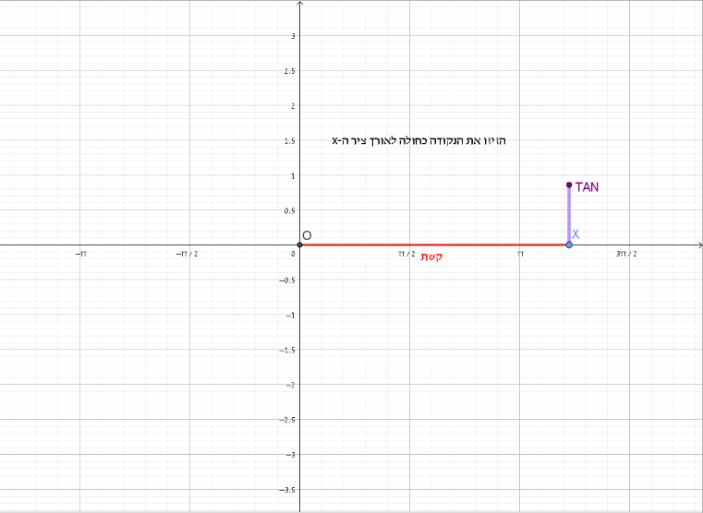

ציור 14

ציור 13

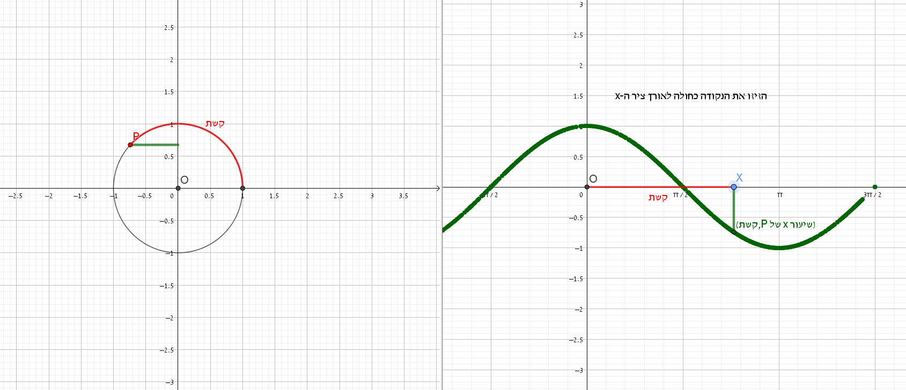

ציור 15

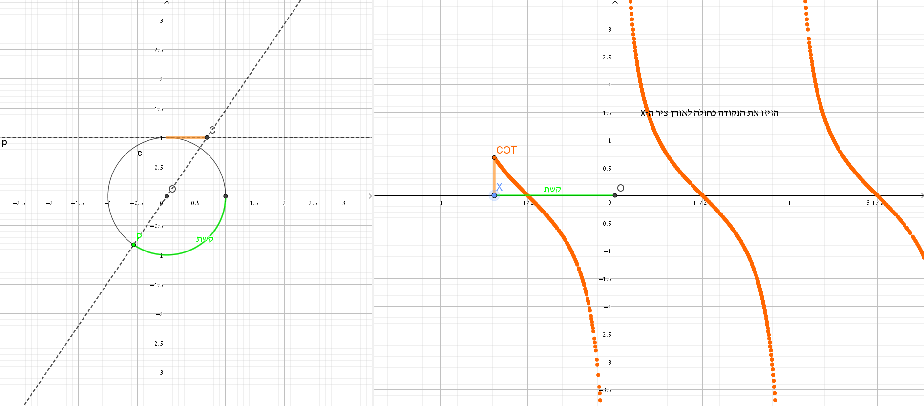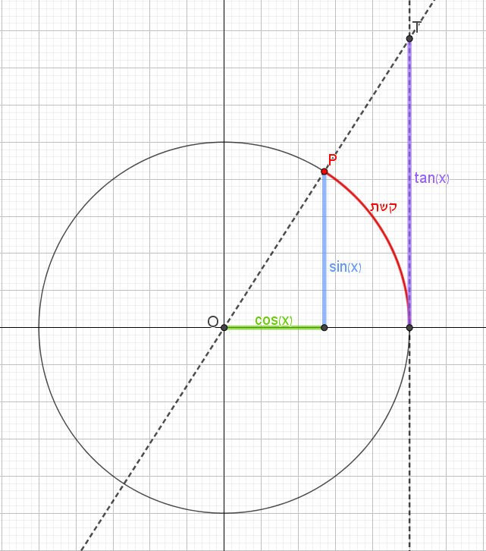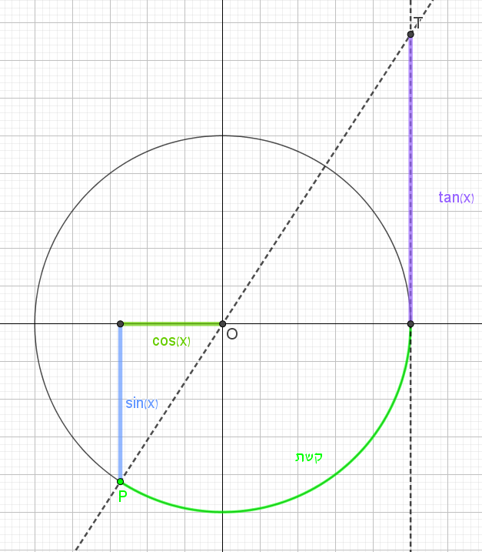

ציור 16

ציור 17

ציור 18

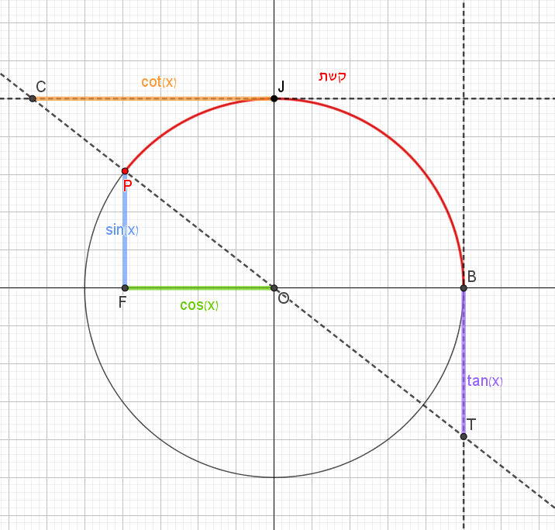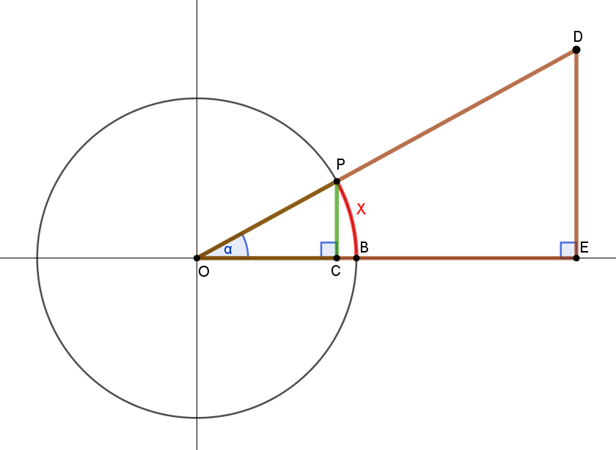

ציור 19

|  |  |  |  |
| --- | --- | --- | --- |
|  |  |  |  |

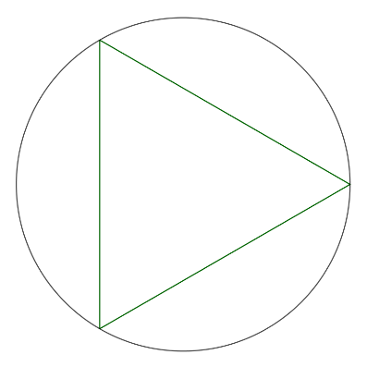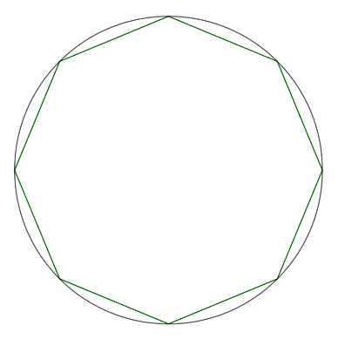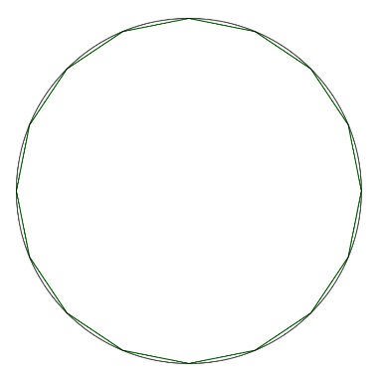

ציור 21

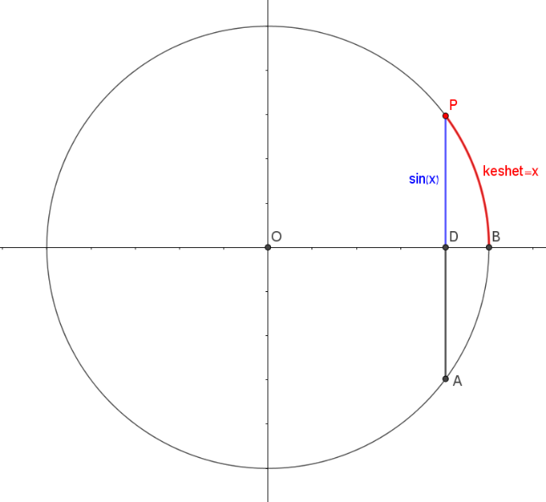

ציור 22

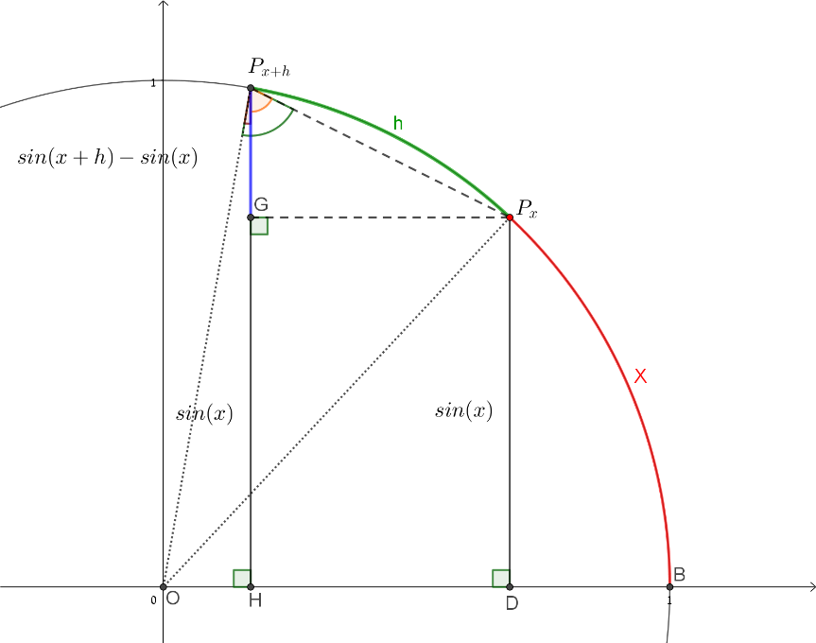

ציור 23